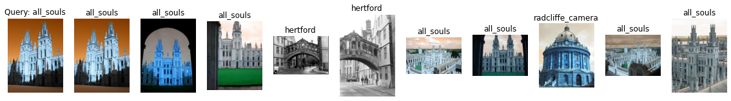

Label: all_souls

Average Precision for query 0: 0.515915633549933

Precision@k for query 0: 0.7

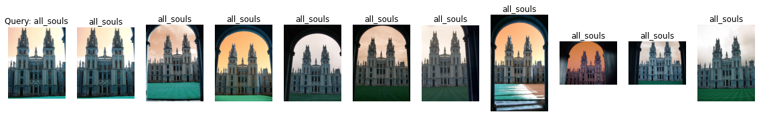

Label: all_souls

Average Precision for query 1: 0.6300937144123524

Precision@k for query 1: 1.0

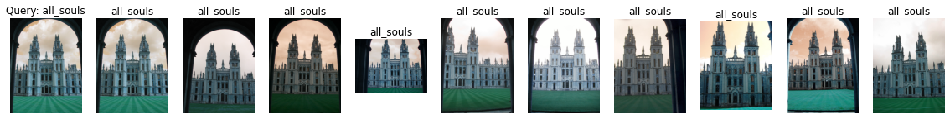

Label: all_souls

Average Precision for query 2: 0.6640008281490287

Precision@k for query 2: 1.0



Label: all_souls

Average Precision for query 3: 0.7115583737568146

Precision@k for query 3: 1.0

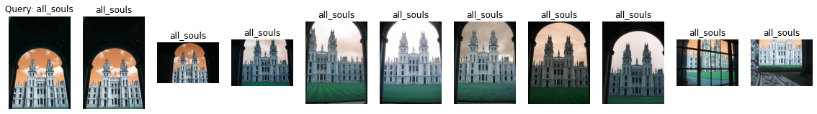

Label: all_souls

Average Precision for query 4: 0.7118638864998296

Precision@k for query 4: 1.0

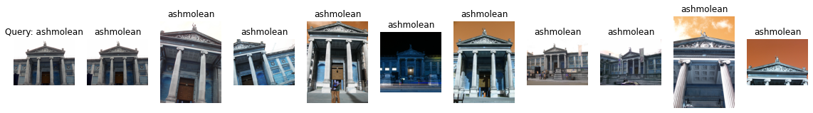

Label: ashmolean

Average Precision for query 5: 0.6897400725782865

Precision@k for query 5: 1.0

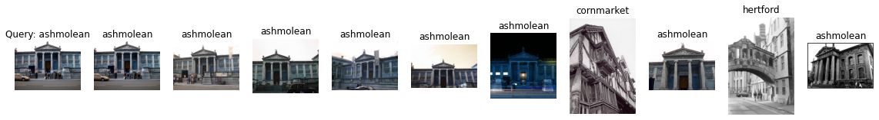

Label: ashmolean

Average Precision for query 6: 0.4505108708908012

Precision@k for query 6: 0.8

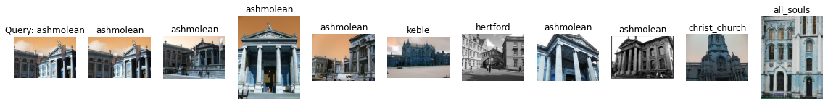

Label: ashmolean

Average Precision for query 7: 0.34494350601318396

Precision@k for query 7: 0.6

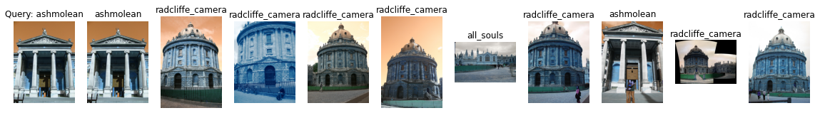

Label: ashmolean

Average Precision for query 8: 0.17870742400927844

Precision@k for query 8: 0.2

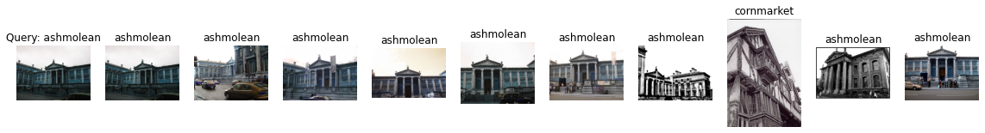

Label: ashmolean

Average Precision for query 9: 0.4267620052484944

Precision@k for query 9: 0.9

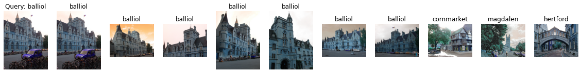

Label: balliol

Average Precision for query 10: 0.6974537037037036

Precision@k for query 10: 0.7

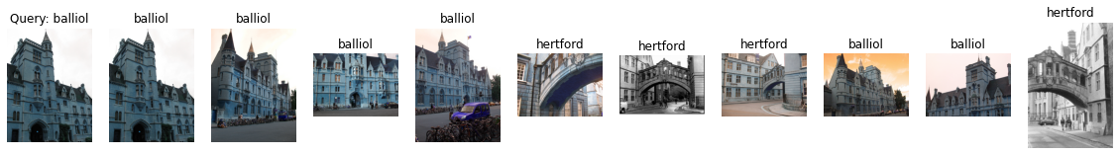

Label: balliol

Average Precision for query 11: 0.555126355833062

Precision@k for query 11: 0.6

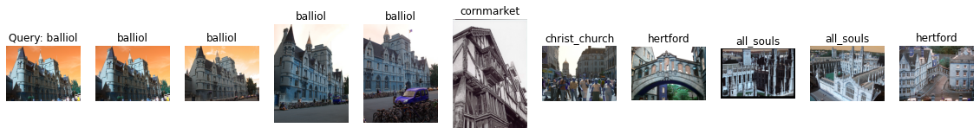

Label: balliol

Average Precision for query 12: 0.4323242268717729

Precision@k for query 12: 0.4

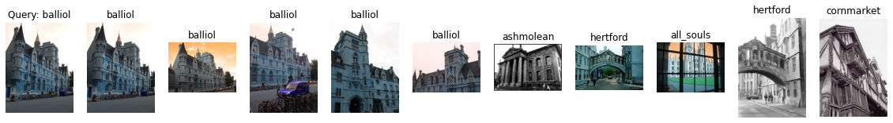

Label: balliol

Average Precision for query 13: 0.5281776213133625

Precision@k for query 13: 0.5

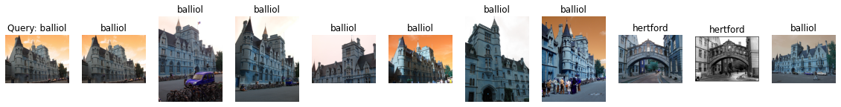

Label: balliol

Average Precision for query 14: 0.7491477087288242

Precision@k for query 14: 0.8

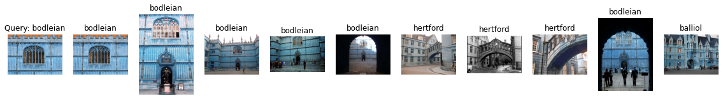

Label: bodleian

Average Precision for query 15: 0.4308351737078812

Precision@k for query 15: 0.6

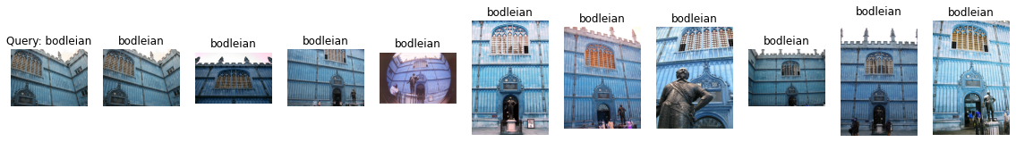

Label: bodleian

Average Precision for query 16: 0.7954909915706642

Precision@k for query 16: 1.0

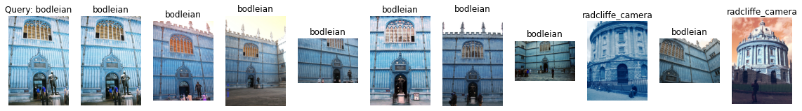

Label: bodleian

Average Precision for query 17: 0.476644297866797

Precision@k for query 17: 0.8

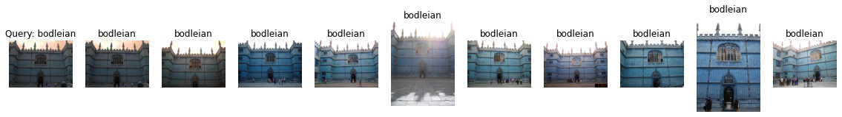

Label: bodleian

Average Precision for query 18: 0.6282905703212905

Precision@k for query 18: 1.0

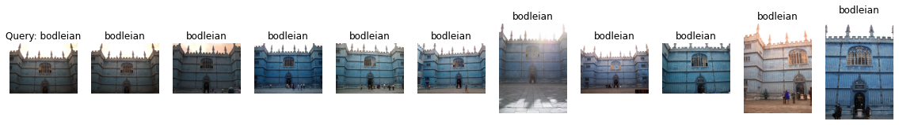

Label: bodleian

Average Precision for query 19: 0.707689090598668

Precision@k for query 19: 1.0

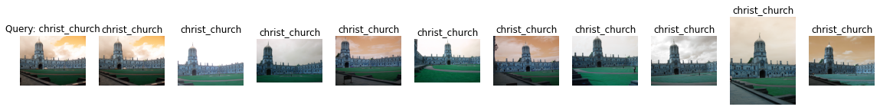

Label: christ_church

Average Precision for query 20: 0.7792207247677619

Precision@k for query 20: 1.0



Label: christ_church

Average Precision for query 21: 0.8171836012223606

Precision@k for query 21: 1.0

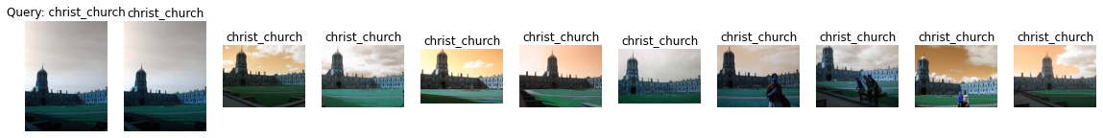

Label: christ_church

Average Precision for query 22: 0.7646007400298362

Precision@k for query 22: 1.0

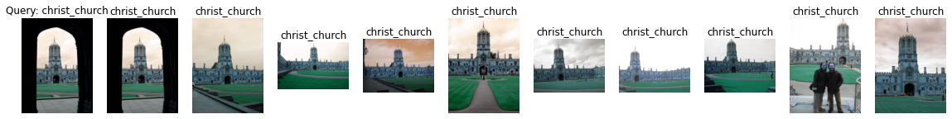

Label: christ_church

Average Precision for query 23: 0.7798893782038567

Precision@k for query 23: 1.0

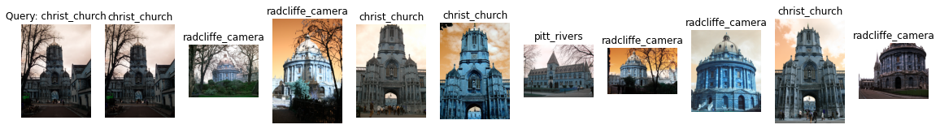

Label: christ_church

Average Precision for query 24: 0.14601451151530548

Precision@k for query 24: 0.4

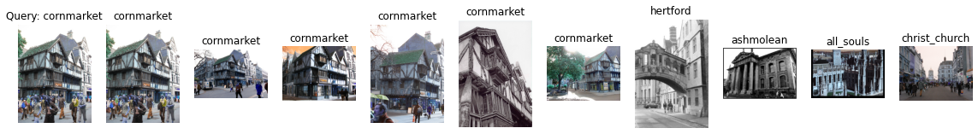

Label: cornmarket

Average Precision for query 25: 0.7309408498148692

Precision@k for query 25: 0.6

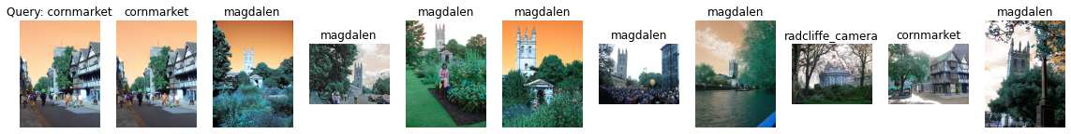

Label: cornmarket

Average Precision for query 26: 0.2100260361030951

Precision@k for query 26: 0.2

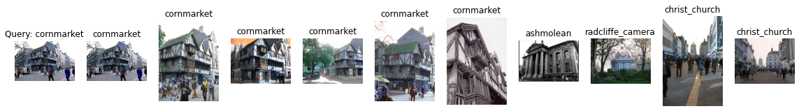

Label: cornmarket

Average Precision for query 27: 0.6968110197739829

Precision@k for query 27: 0.6

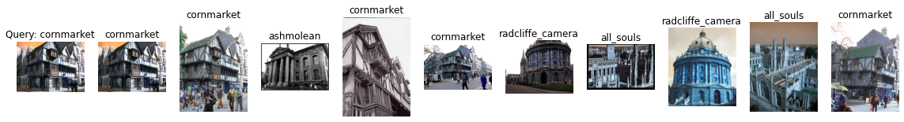

Label: cornmarket

Average Precision for query 28: 0.48982403409665726

Precision@k for query 28: 0.5

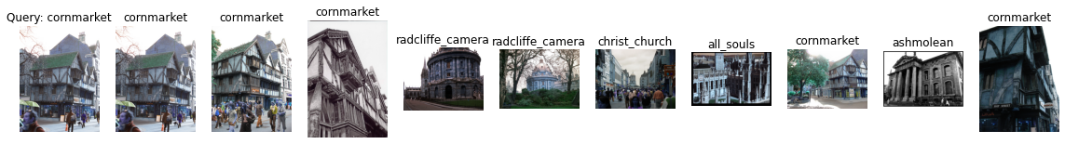

Label: cornmarket

Average Precision for query 29: 0.5538298349090698

Precision@k for query 29: 0.5

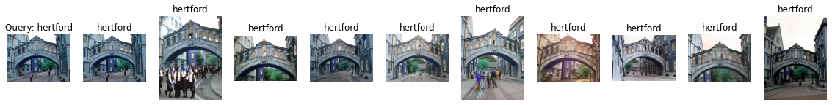

Label: hertford

Average Precision for query 30: 0.8307714454811324

Precision@k for query 30: 1.0

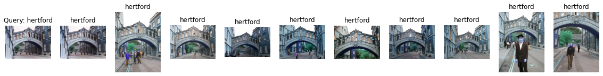

Label: hertford

Average Precision for query 31: 0.7597880544890232

Precision@k for query 31: 1.0

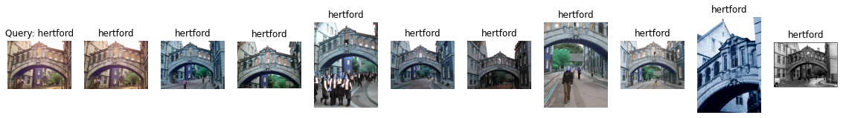

Label: hertford

Average Precision for query 32: 0.6566336925027484

Precision@k for query 32: 1.0

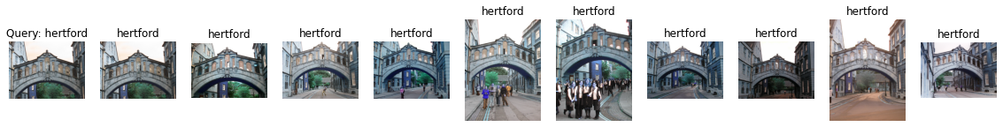

Label: hertford

Average Precision for query 33: 0.8494712142644781

Precision@k for query 33: 1.0

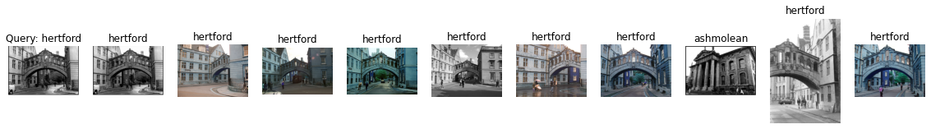

Label: hertford

Average Precision for query 34: 0.7152916229248184

Precision@k for query 34: 0.9

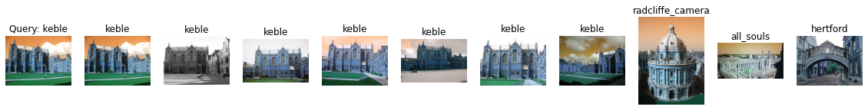

Label: keble

Average Precision for query 35: 1.0

Precision@k for query 35: 0.7

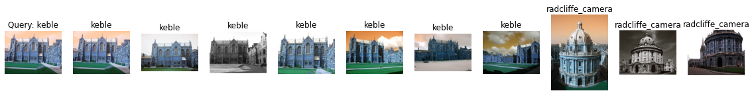

Label: keble

Average Precision for query 36: 1.0

Precision@k for query 36: 0.7

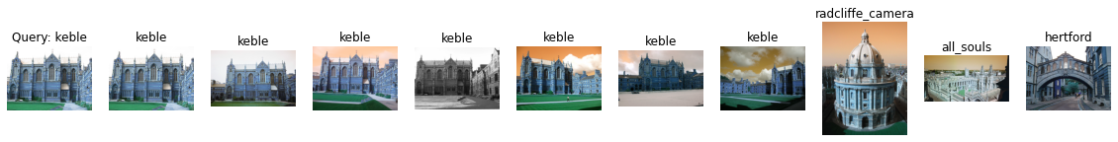

Label: keble

Average Precision for query 37: 1.0

Precision@k for query 37: 0.7

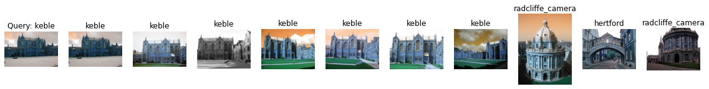

Label: keble

Average Precision for query 38: 1.0

Precision@k for query 38: 0.7

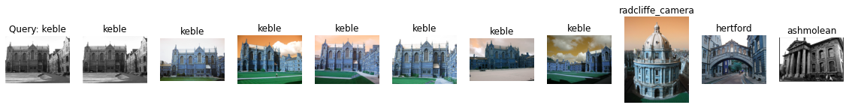

Label: keble

Average Precision for query 39: 1.0

Precision@k for query 39: 0.7

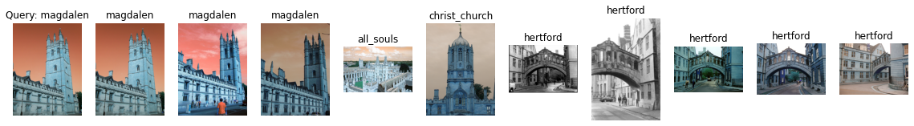

Label: magdalen

Average Precision for query 40: 0.128604683611479

Precision@k for query 40: 0.3

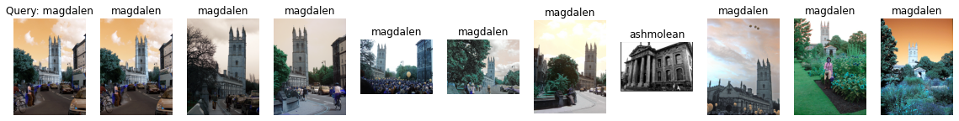

Label: magdalen

Average Precision for query 41: 0.45687927035631504

Precision@k for query 41: 0.9

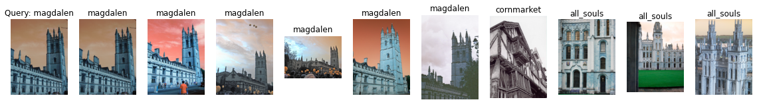

Label: magdalen

Average Precision for query 42: 0.21285719252354116

Precision@k for query 42: 0.6

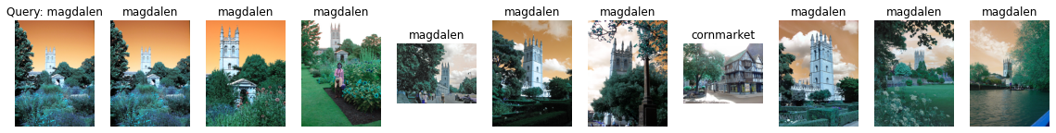

Label: magdalen

Average Precision for query 43: 0.5145196212009894

Precision@k for query 43: 0.9

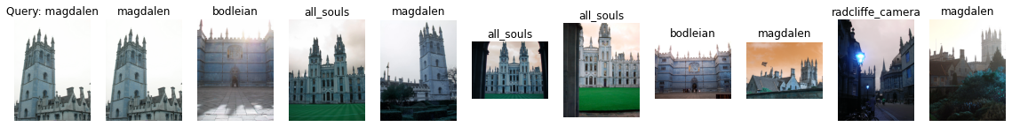

Label: magdalen

Average Precision for query 44: 0.2171298668535957

Precision@k for query 44: 0.4

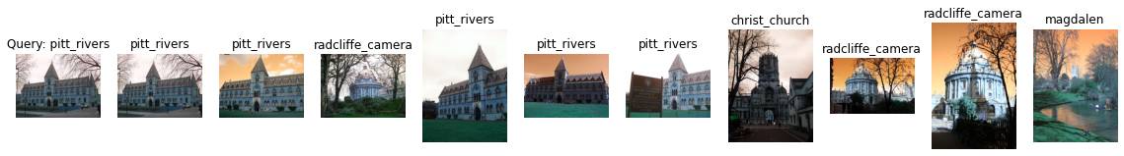

Label: pitt_rivers

Average Precision for query 45: 0.8138888888888888

Precision@k for query 45: 0.5

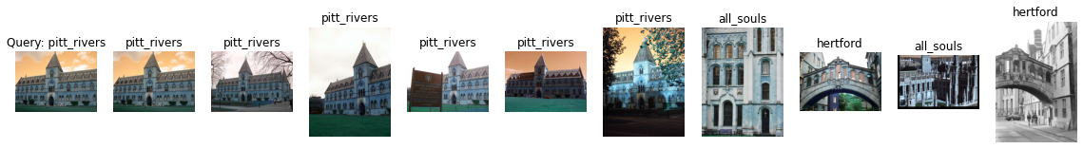

Label: pitt_rivers

Average Precision for query 46: 1.0

Precision@k for query 46: 0.6

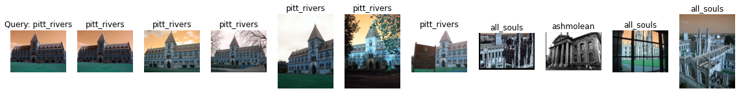

Label: pitt_rivers

Average Precision for query 47: 1.0

Precision@k for query 47: 0.6

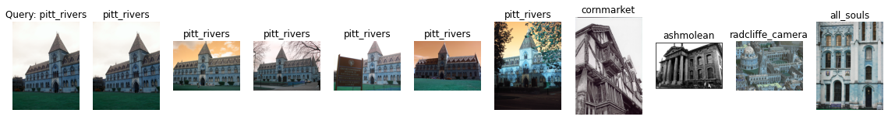

Label: pitt_rivers

Average Precision for query 48: 1.0

Precision@k for query 48: 0.6



Label: pitt_rivers

Average Precision for query 49: 0.9761904761904762

Precision@k for query 49: 0.6

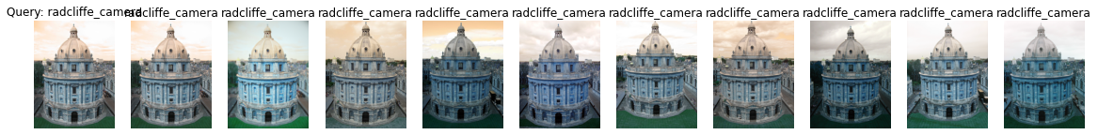

Label: radcliffe_camera

Average Precision for query 50: 0.7651093009605737

Precision@k for query 50: 1.0



Label: radcliffe_camera

Average Precision for query 51: 0.7874022656769603

Precision@k for query 51: 1.0

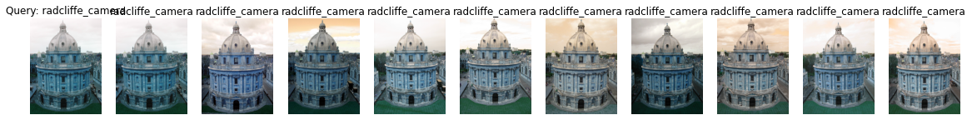

Label: radcliffe_camera

Average Precision for query 52: 0.811999907595698

Precision@k for query 52: 1.0

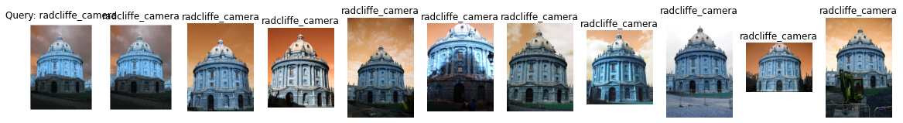

Label: radcliffe_camera

Average Precision for query 53: 0.8281651979226666

Precision@k for query 53: 1.0

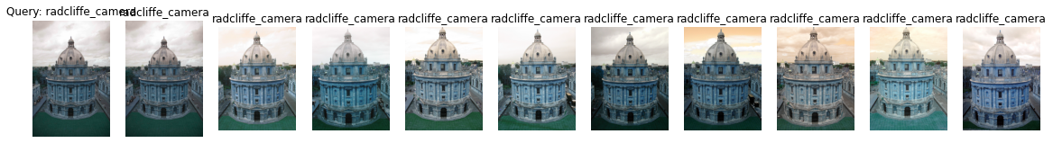

Label: radcliffe_camera

Average Precision for query 54: 0.7891633863218154

Precision@k for query 54: 1.0

mAP = 0.6619542340695641